CSA1519-CLOUD COMPUTING FOR BIG DATA ANALYTICS
LAB EXPERIMENTS
4. Create a simple cloud software application for Car Booking Reservation System using any Cloud Service Provider to demonstrate SaaS.
AIM
To create a simple cloud software application for a Car Booking Reservation System using Zoho Creator in order to demonstrate the Software as a Service (SaaS) cloud computing model.
MATERIALS REQUIRED
Hardware Requirements
- Desktop / Laptop Computer
- Minimum 4 GB RAM
Software Requirements
- Web Browser (Google Chrome / Firefox)
- Zoho Account
- Internet Connection
Cloud Platform
- Zoho Creator (Online SaaS Platform)

PROCEDURE
Step 1: Login to Zoho Creator
- Open browser and go to https://creator.zoho.com
- Login using Zoho credentials
- Click Create App
- Select Create from Scratch
- App Name: Car Booking Reservation System
Step 2: Create Three Forms
Form 1: Car Details
Form Name: Car_Details
Field Name | Field Type
Car_ID | Single Line
Car_Model | Single Line
Car_Type | Dropdown (Sedan, SUV, Hatchback)
Registration_Number | Single Line
Price_Per_Day | Number
Availability_Status | Dropdown (Available / Booked)

Form 2: Customer Details
Form Name: Customer_Details
Field Name | Field Type
Customer_Name | Single Line
Phone_Number | Phone
Email | Email
Driving_License_Number | Single Line

Form 3: Booking Details
Form Name: Booking_Details
Field Name | Field Type
Customer | Lookup (Customer_Details)
Car | Lookup (Car_Details)
Booking_Date | Date
Pickup_Date | Date
Return_Date | Date
Total_Amount | Number

Step 4: Create Reports
Create the following reports:
- Car Details
- Customer Details
- Booking Details
Step 8: Create Dashboard Page
Add a page with:
- Button → Car Details
- Button → Customer Details
- Report → Booking Details

OUTPUT

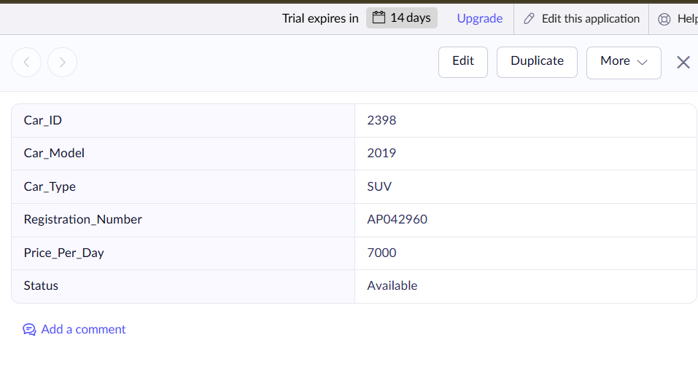
Figure 1: Car Details

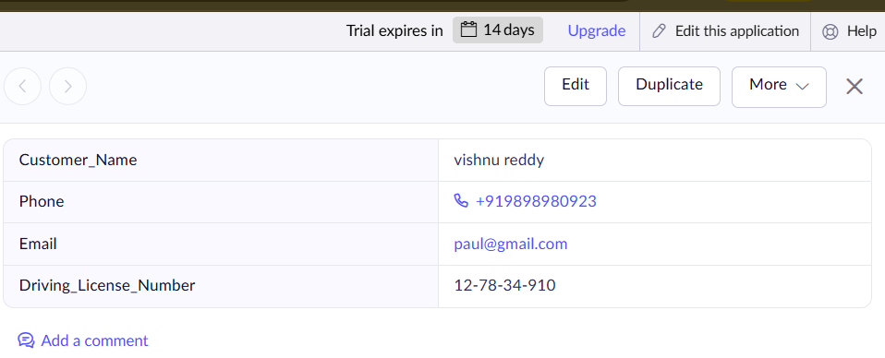
Figure 2: Customer Details
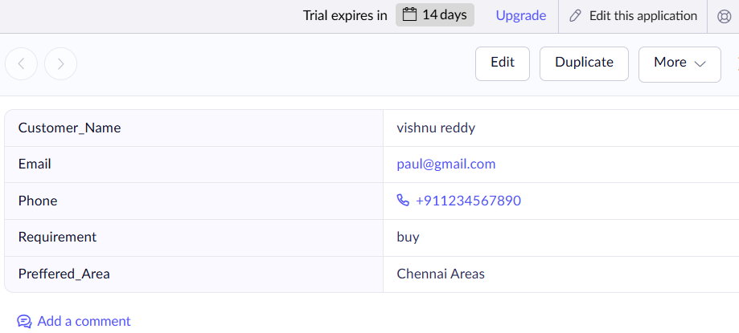

Figure 3: Booking Details
RESULTS
The cloud-based Car Booking and Reservation System was successfully designed, developed, and deployed using Zoho Creator as a Software as a Service (SaaS) application.

